PROJECT NAME: MATH AI TUTOR
PROJECT GUIDE: Dr. M. Saraswathi
PROJECT TEAM: Stutipriya Shadangi, Kongara Dheeraj from III CSE, SCSVMV

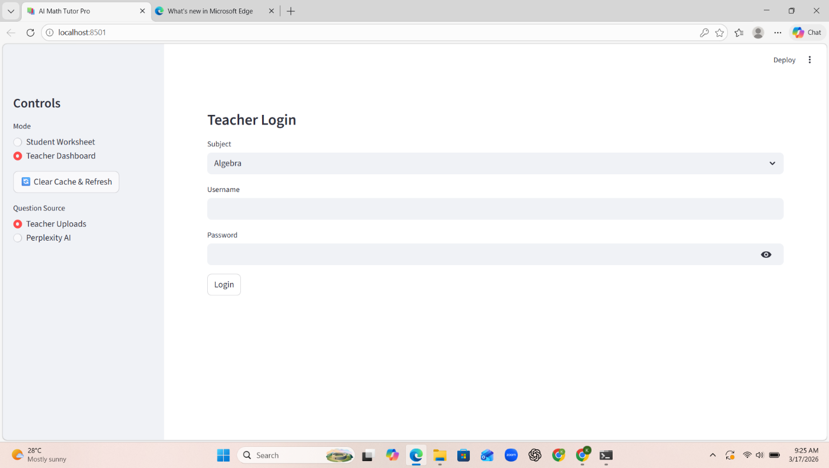

Teacher Login page:
- The teacher chooses the subject, enters username and password, then login.
- Login made simple.

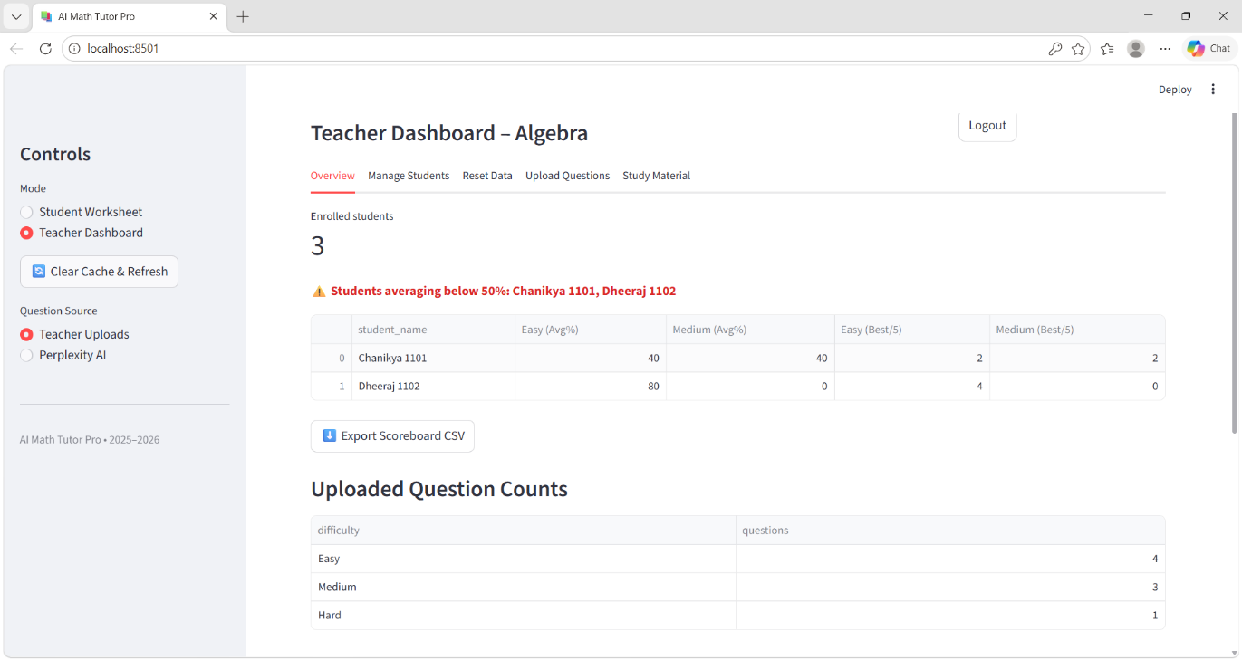

Teacher Dashboard:
- Displays the count of enrolled students, students’ performance and uploaded questions count.
- The students’ data can be exported into an excel file.
- Student Drill Down – displays selected student performance in detail. Can also be exported in excel file.

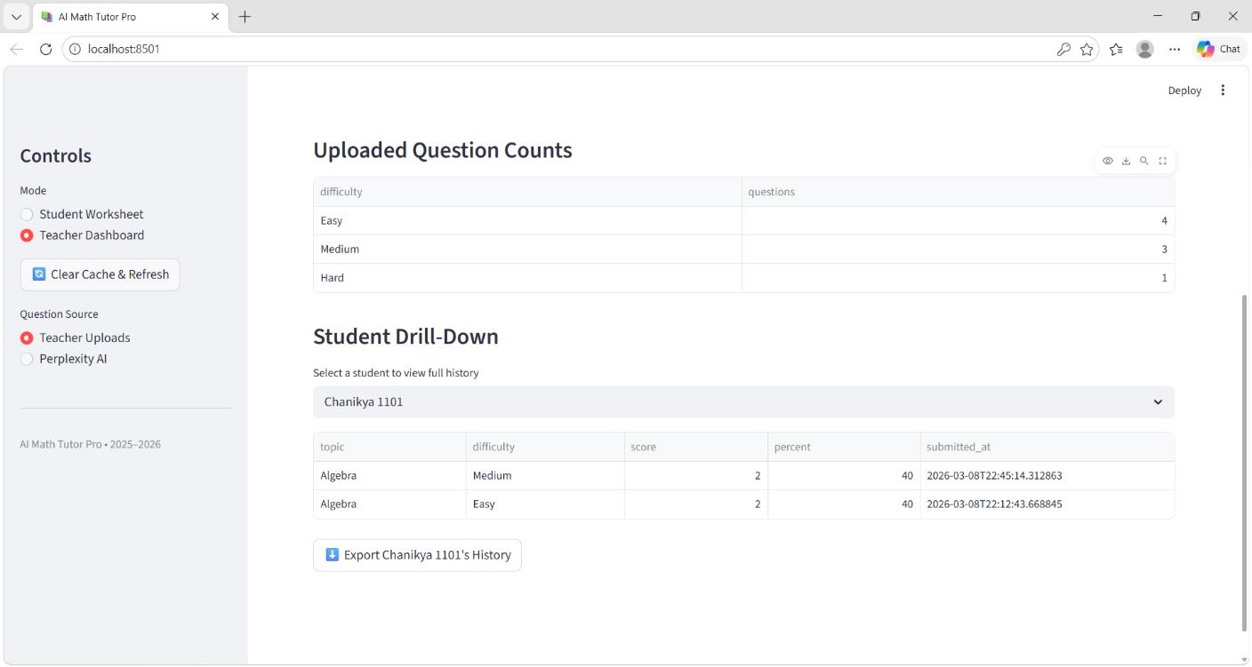

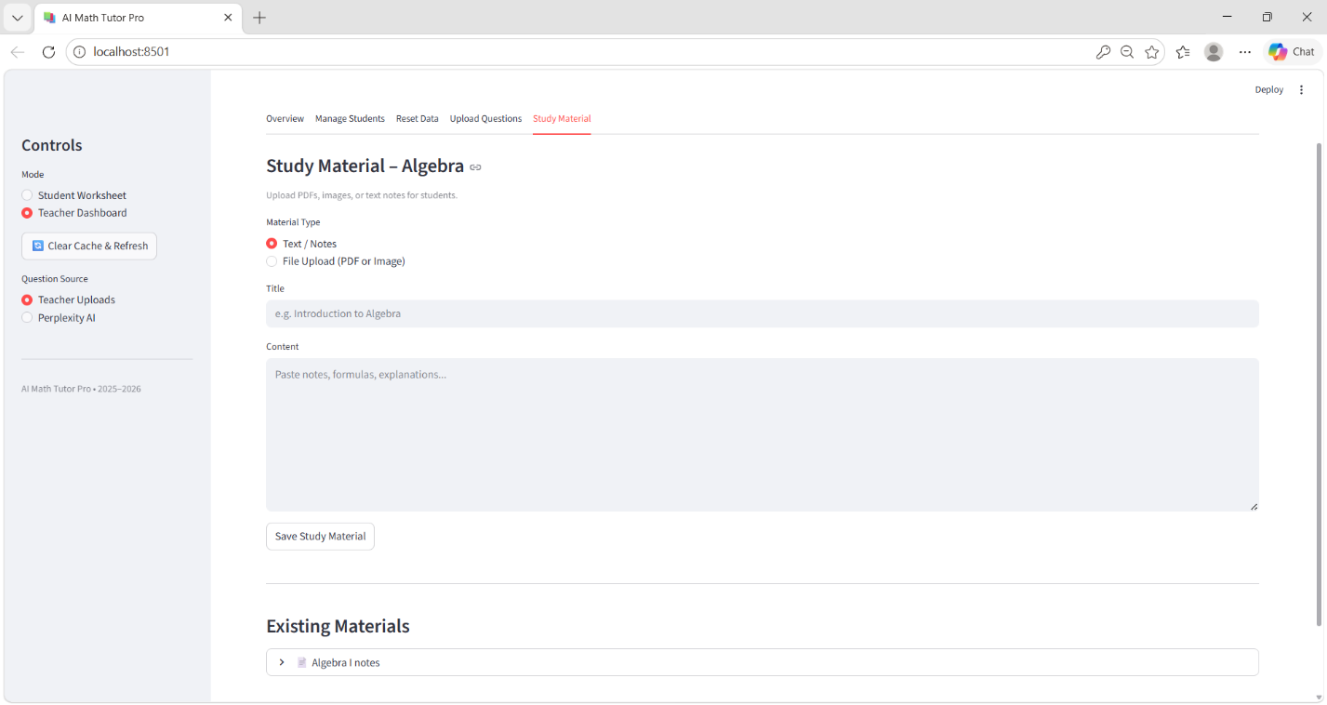

Study Material:
- Teachers can upload study materials for students.
- Material can be in the form of text, pdf or images.

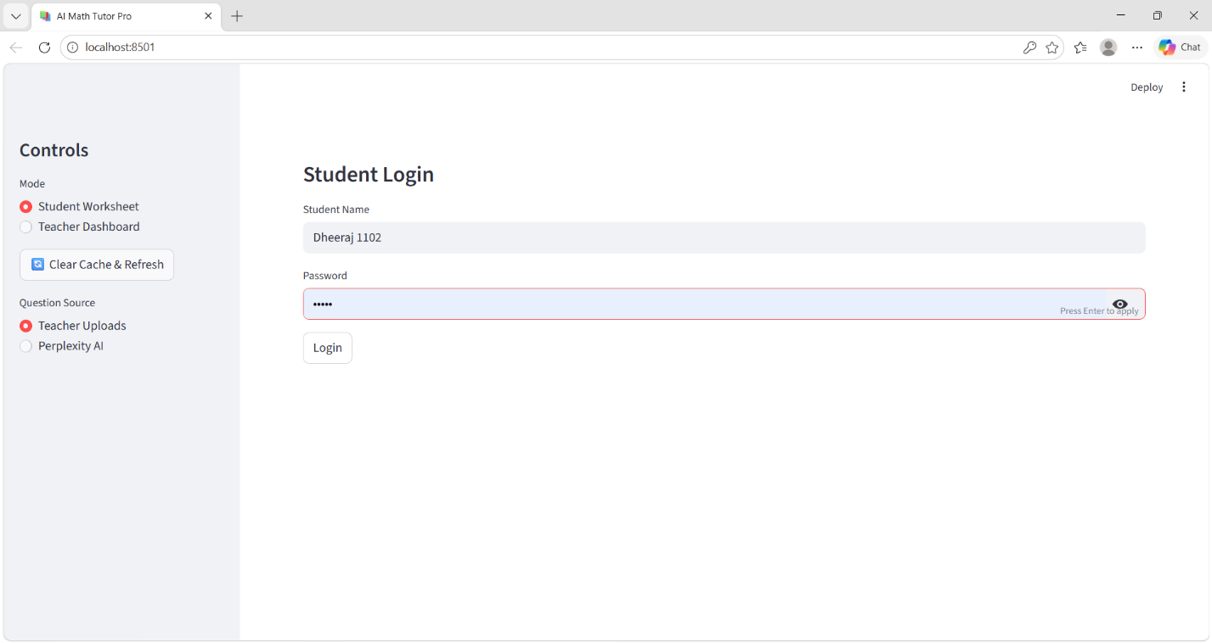

Student Login Page:
- Student login using student name and password.
- Student name is a combination of Student name and register number (ex: Dheeraj 1102).
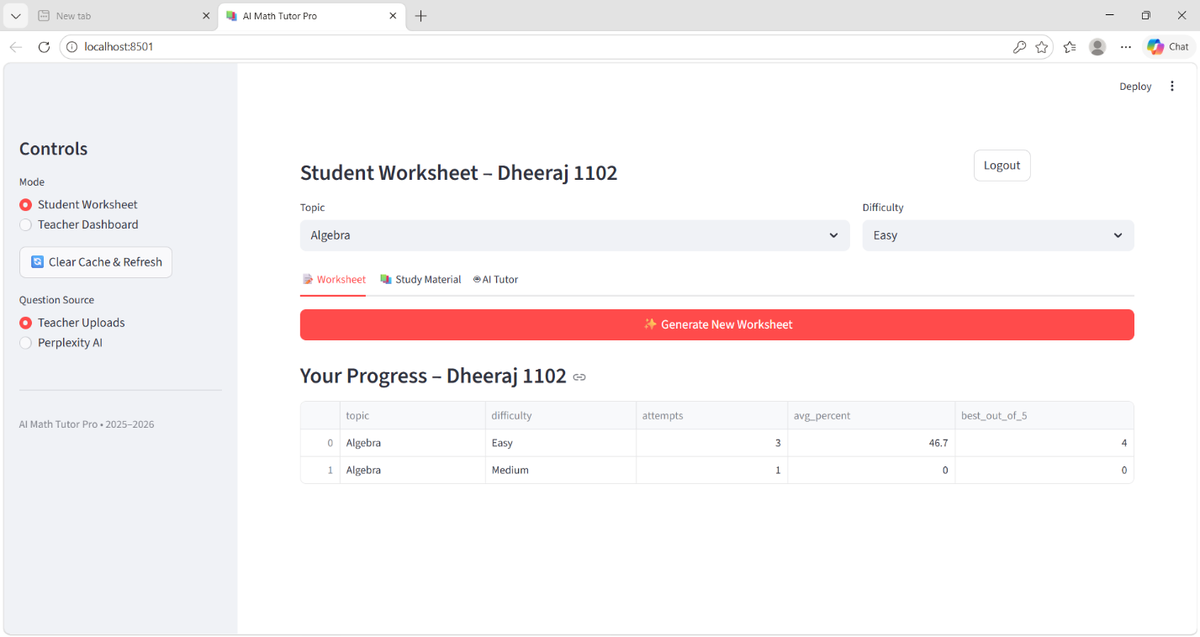

Student worksheet:
- Dashboard displays the progress of students’ performance.
- Generate worksheets using the notes provided or using perplexity AI

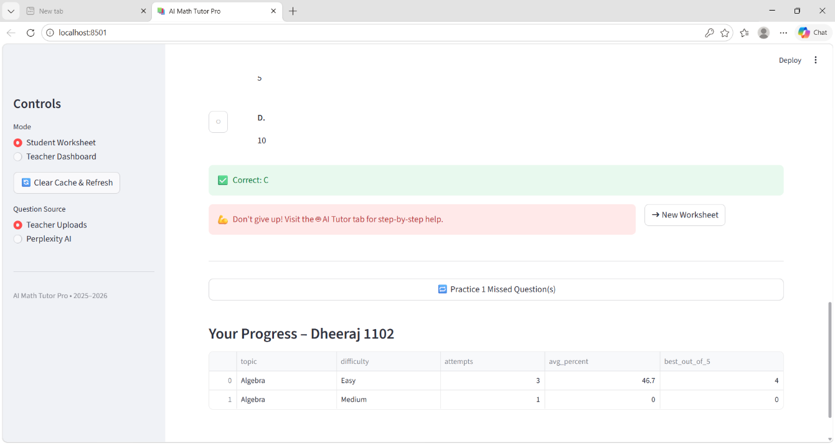

Worksheet generation:
- Students answer the worksheets and submit. Wrong answers are given under practice.
- Students can take help from an AI Tutor for help.
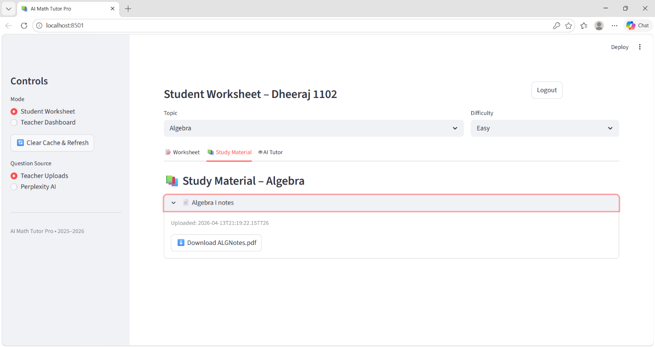

Study materials:
- They can download or access the materials given by the teacher.

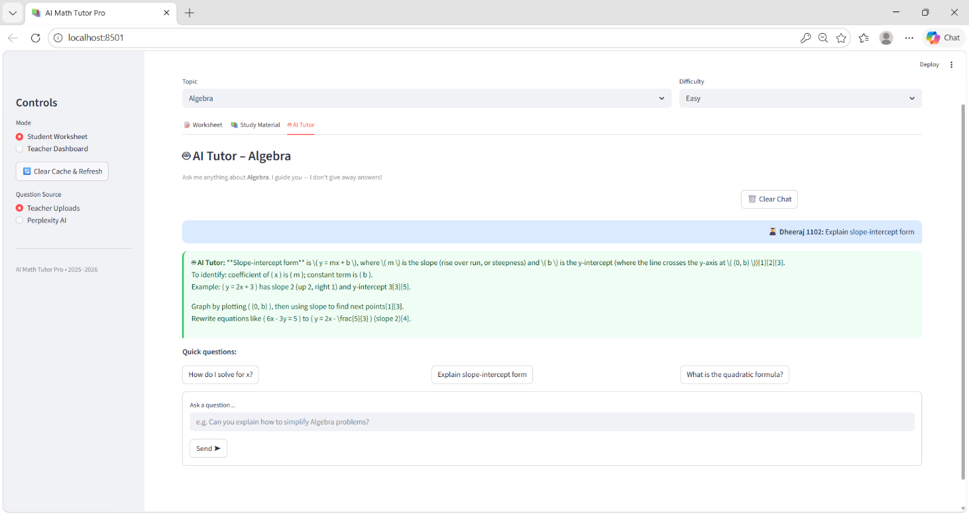

AI Tutor:
- In build ai tutor for the students for quick understanding of problems.
- Quick and easy understanding answers.

